Extra Practical :- 2
AIM :- Develop a simple PHP web application for an online ordering system where user have to give email id and order status (Yes / No). After submission, the system should send a confirmation email to the user HTML format.

INPUT Files :-

File - 1 :- { index2.php }
<!DOCTYPE html>
<html>
<head>
<title>Online Order Form</title>
</head>
<body>

<h2>Online Order Form</h2>

<form action="send-email.php" method="POST">

<label>Email:</label><br>
<input type="email" name="email" required><br><br>

<label>Order Status:</label><br>
<select name="status" required>
<option value="Yes">Yes</option>
<option value="No">No</option>
</select><br><br>

<input type="submit" value="Submit Order">

</form>

</body>
</html>

File - 2 :- { send-email.php }
<?php
use PHPMailer\PHPMailer\PHPMailer; use PHPMailer\PHPMailer\Exception; use PHPMailer\PHPMailer\SMTP;

require 'src/Exception.php'; require 'src/PHPMailer.php'; require 'src/SMTP.php';
$mail = new PHPMailer(true); try {
$mail->isSMTP();
$mail->Host = 'smtp.gmail.com';
$mail->SMTPAuth = true;
$mail->Username = 'shravanmali7810@gmail.com';
$mail->Password = 'idunawahnddaeesy'; // App password
$mail->SMTPSecure = PHPMailer::ENCRYPTION_STARTTLS;
$mail->Port = 587;

$email = isset($_POST['email']) ? $_POST['email'] : '';
$status = isset($_POST['status']) ? $_POST['status'] : '';

if (empty($email)) {
throw new Exception("Email is required.");
}

$mail->setFrom('shravanmali7810@gmail.com', 'Order System');
$mail->addAddress($email);

$mail->isHTML(true);
$mail->Subject = "Order Confirmation";

$mail->Body = "
<html>
<body>
<h2 style='color:blue;'>Order Confirmation</h2>
<p><strong>Email:</strong> " . htmlspecialchars($email) . "</p>
<p><strong>Order Status:</strong> " . htmlspecialchars($status) . "</p>

<p>Thank you for your order.</p>
<hr>
<p>Regards,<br>Online Order System</p>
</body>
</html>
";

$mail->AltBody = "Email: $email | Order Status: $status";

$mail->send();
echo "<h3>Email Sent Successfully to $email</h3>";

} catch (Exception $e) {
echo "Message could not be sent. Error: {$mail->ErrorInfo}";
}
?>
OUTPUT :-
- Home page
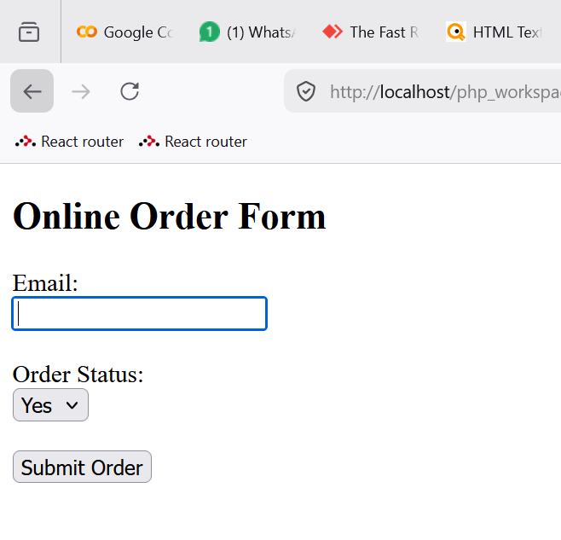

- Entered the recipient
Details
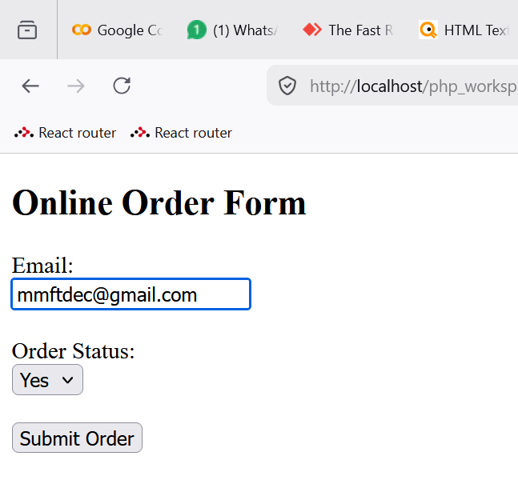
- Order acknowledgement message
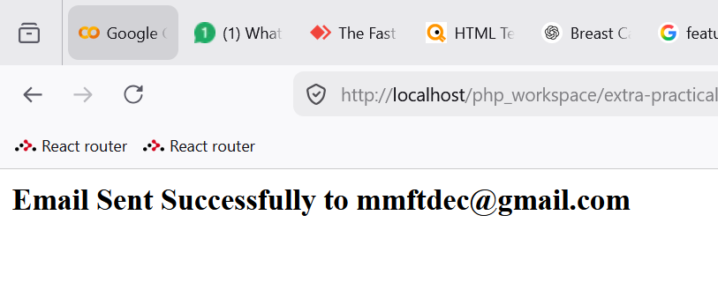
- Email screenshot received
